Ideation Phase
Define Problem Statements
Date | 4 March 2026
Team ID | SWTID-2026-8059
Project Name | Automating Data Import and Relationship Mapping Using Import Sets & Dot Walking
Maximum Marks | 4 Marks

Problem Statement(Definition):
In many organizations, employee information is maintained in external systems such as HR applications or spreadsheets. These systems regularly generate data files containing employee details like Name, Email, Department, and Manager. Manually entering or updating this information in servicenow is time-consuming, inefficient, and prone to human errors.
Additionally, during the incident management process, when an incident is assigned to an employee, it is often necessary to identify and contact the manager of the employee’s department for communication or escalation. Without an automated mechanism, users must manually search through multiple records to find the manager’s email, which slows down the workflow and reduces efficiency.
The Problem: Data Incompatibility
Organizations often need to move data from external sources (like Excel, legacy databases, or third-party tools) into servicenow. The "problem" is that external data is rarely formatted exactly like servicenow’s internal tables. Moving it directly could result in:
- Data Corruption : Overwriting critical system fields.
- Performance Issues: Slowing down production tables during large uploads.
- Formatting Errors : Date formats or choice lists not matching.

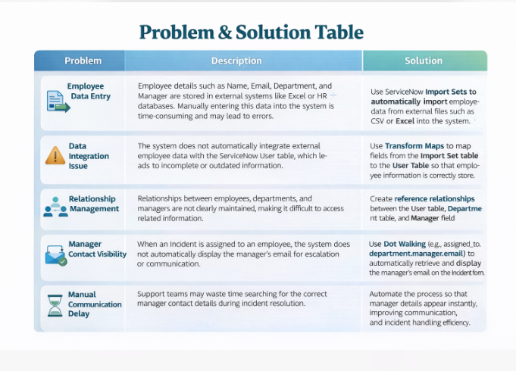

Process of Automatic Data Import:

